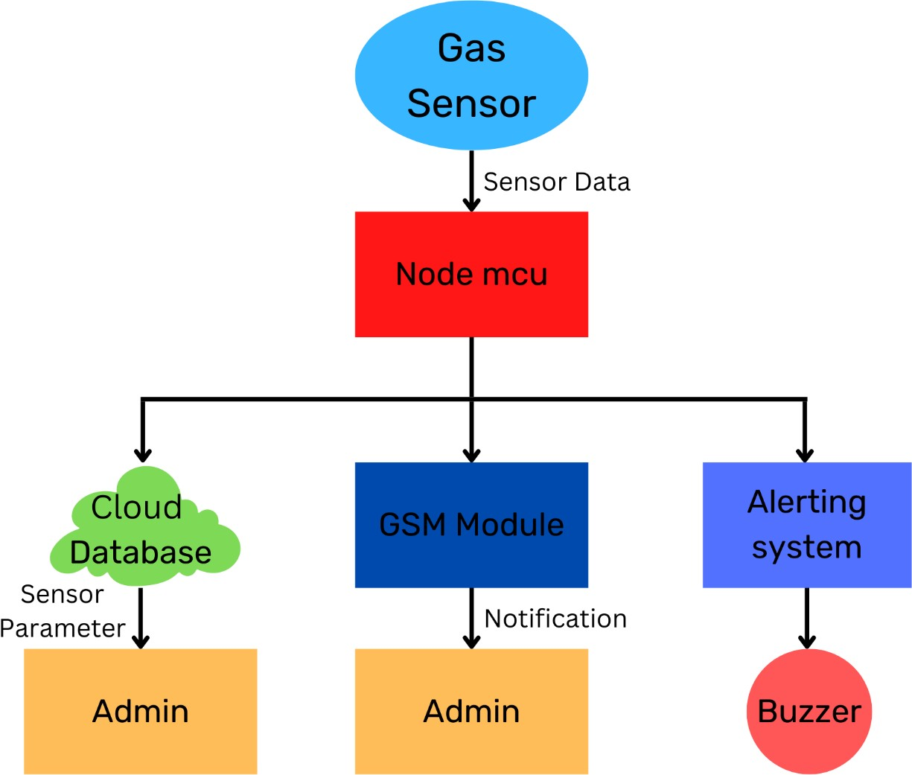
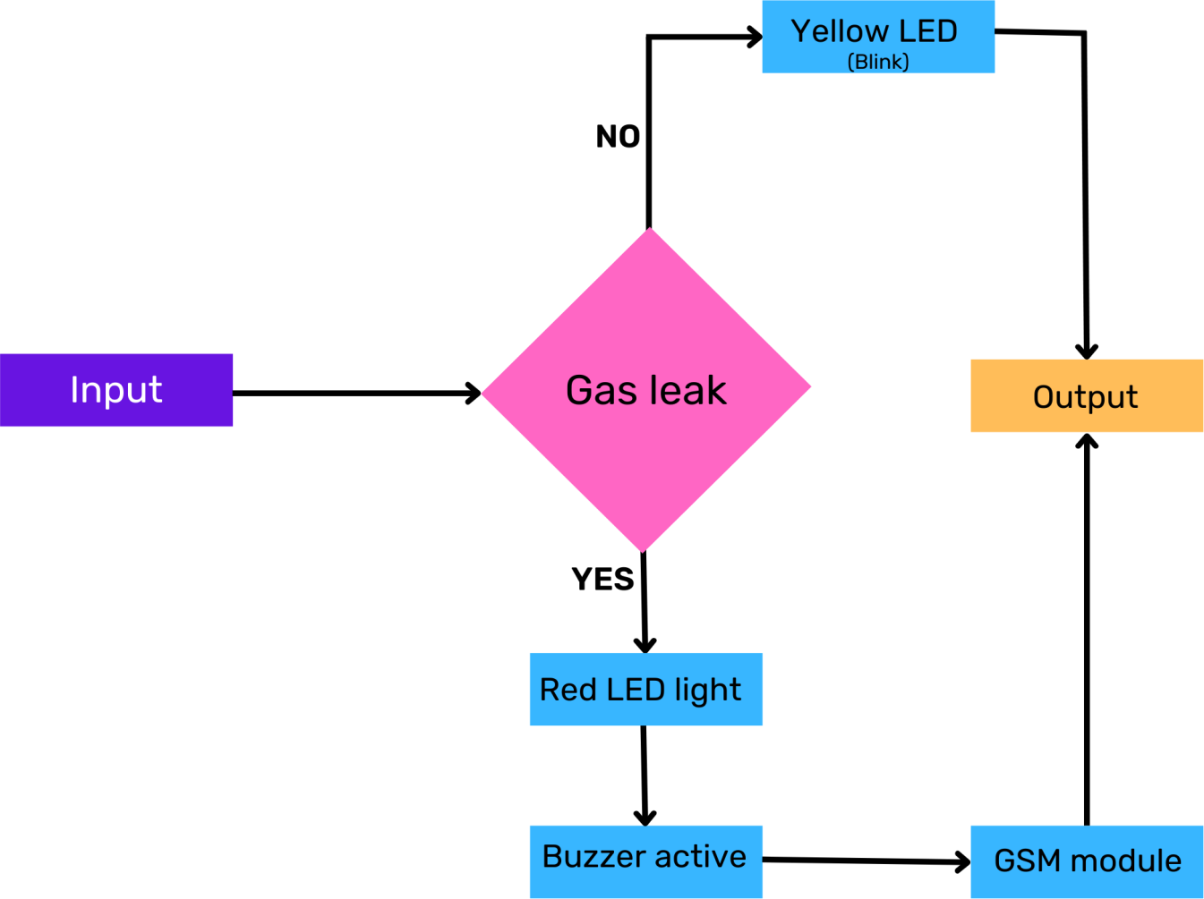
Project Design Phase-II Data Flow Diagram & Flow Chart

Date | 17 October 2022
Team ID | PNT2022TMID12971
Project Name | Gas Leakage Monitoring & Alerting System For Industries
Maximum Marks | 4 Marks

Data Flow Diagram:
A Data Flow Diagram (DFD) is a traditional visual representation of the information flows within a system. A neat and clear DFD can depict the right amount of the system requirement graphically. It shows how data enters and leaves the system, what changes the information, and where data is stored.

User Stories:

User Type | Functional Requirements (EPIC) | User Story Number | User Story/Task | Acceptance Criteria | Priority | Release
Customer (application) | Registration | USN-1 | As a user, I can register for the application by entering my email, password, and confirming my  password. | I can access my account  / dashboard | High | Sprint-1
 |  | USN-2 | As a user, I will receive confirmation email once I have registered for the  application | I can receive confirmatio n email & click confirm | Medium | Sprint-1
 |  | USN-3 | As a user, I can register for the application through Gmail |  | Medium | Sprint-1
 | Login | USN-4 | As a user, I can log into the application by entering email  & password |  | High | Sprint-1
 | Dashboard | USN-5 | As a user, I can login with my credentials to see my dashboard | I will be able to see my dashboard and the  application | High | Sprint-2
Customer (Web user) | Dashboard | USN-6 | As a web user, I will go to the application’s URL and login by entering my  credentials | I will be able to login and view my dashboard | Medium | Sprint-2
Customer Care Executive | Helping the customers | USN-7 | As a customer care person, I will respond to the customer’s queries | I will be able to see the customer’s difficulties, queries and  feedback | High | Sprint-3
Administrat or | Working with data | USN-8 | As an administrator, I can login to the application’s  server | I will be able to view the applications  data server | High | Sprint-3

Asking and responding
USN-9
As an administrator, I can ask and respond to the customer’s
questions
I will be able to answerable to the customers
Medium
Sprint-4

Maintaining the database
USN-10
As an administrator, I will be able to view the database
I will be able to view, modify and maintain the
application’
s database
High
Sprint-4

Managing the overall process
USN-11
As an administrator, I can control the overall process
I can control and maintain the overall application’
s process
High
Sprint-4

